**Practical 7**

**Configuring server and client**

**Aim:** Configure the following Servers using a suitable topology

1. Configure DHCP
2. Configure DNS
3. Configure HTTP
4. Configure Telnet
5. Configure FTP
6. **Configure DHCP**

DHCP, which stands for Dynamic Host Configuration Protocol, is a standardized network protocol used to automatically assign and manage IP addresses and other network configuration parameters to devices on a network. It is an essential component of most modern computer networks, including local area networks (LANs) and larger networks such as the Internet.

The primary purpose of DHCP is to simplify the process of configuring IP addresses and related network settings for devices, such as computers, smartphones, tablets, and other network-enabled devices. Without DHCP, network administrators would need to manually assign unique IP addresses to each device on the network, which could be time-consuming and prone to errors.

In order to configure the DHCP server, we do the following

We use the following topology

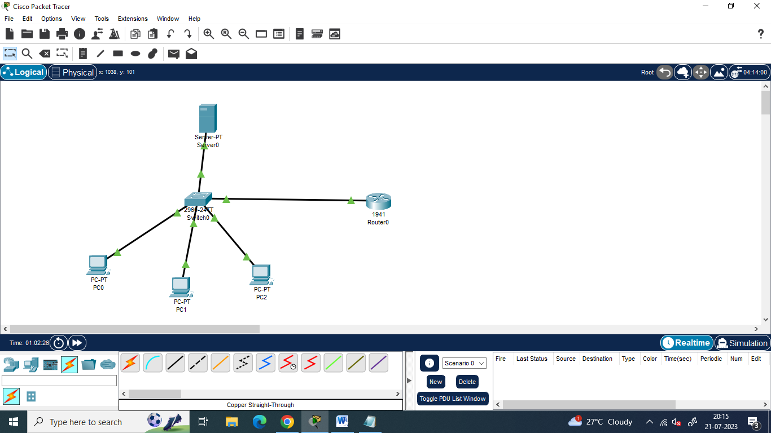

We assign the following IP addresses

|  | IP address | Subnet  Mask |
| --- | --- | --- |
| Router  Interface G0/0 | 10.0.0.1 | 255.0.0.0 |
| Server | 10.0.0.2 |
| PC0 | Will be assigned by DHCP server |
| PC1 |
| PC2 |

**Configuring the Devices:**

**Router0:**

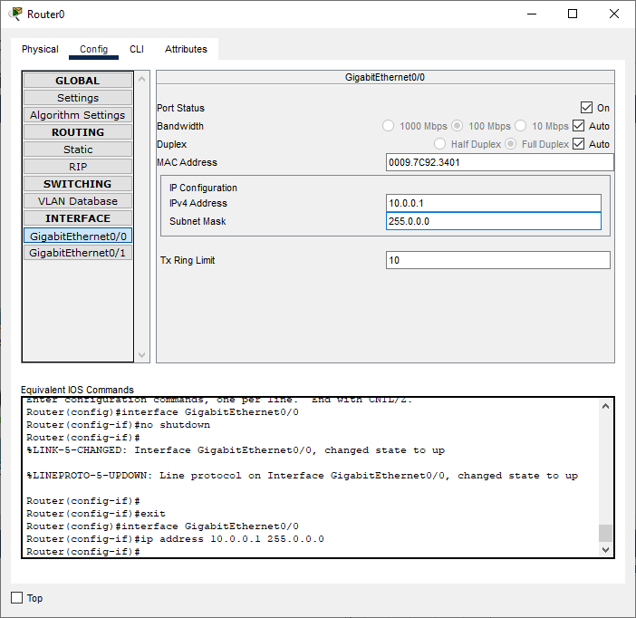

**Server:**

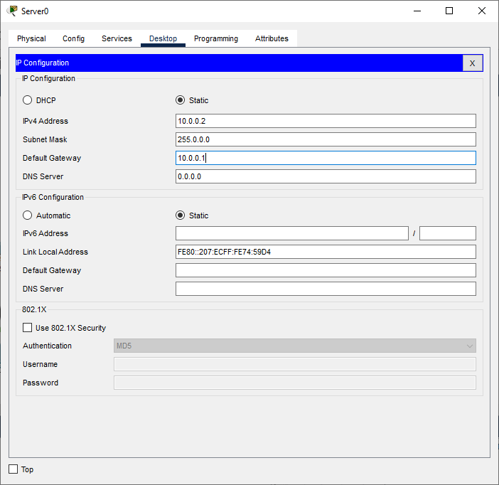

**Setting the Server for DHCP service:**

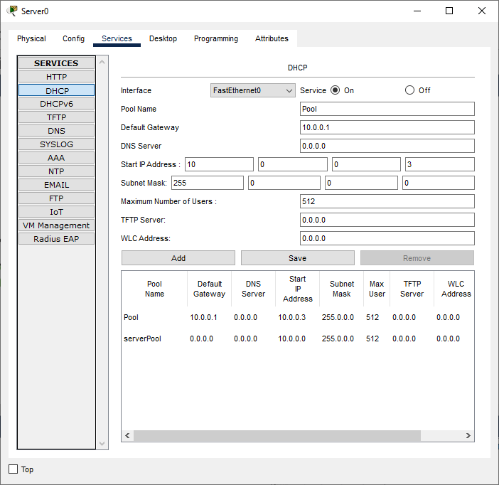

In order to verify the working of the DHCP protocol, we do the following for all the PCs

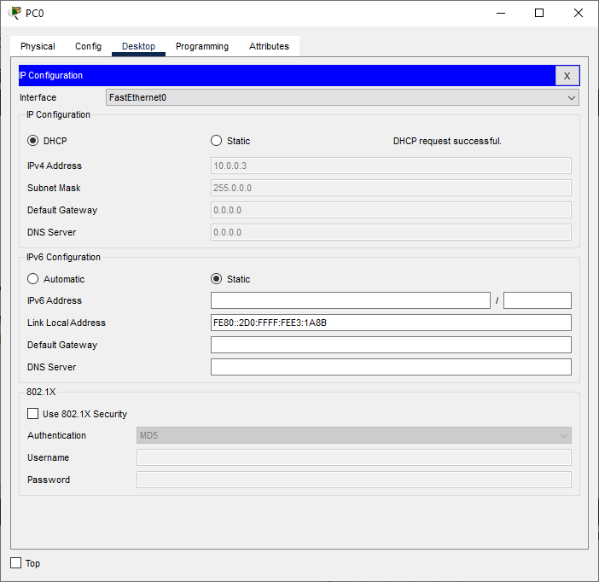

Hence DHCP protocol is verified

| For Video demonstration of the DHCP, scan the QR-code |  |
| --- | --- |

1. **Configure DNS**

DNS stands for Domain Name System. It is a fundamental part of the internet infrastructure and serves as a decentralized system for translating human-readable domain names into IP addresses, which are used by computers to identify each other on the internet.

When we type a website's domain name into your web browser (e.g., www.ismile.com), the DNS comes into play. The DNS acts as a phonebook for the internet, converting the domain name into the corresponding IP address (e.g., 192.0.2.1) that represents the actual location of the website's server on the internet.

We use the following topology



We use the following IP addresses for the given topology

|  | IP address | Default Gateway | Subnet  Mask | DNS  Server |
| --- | --- | --- | --- | --- |
| Router  Interface G0/0 | 10.0.0.1 |  | 255.0.0.0 | 10.0.0.2 |
| Server | 10.0.0.2 | 10.0.0.1 |
| PC0 | 10.0.0.3 |
| PC1 | 10.0.0.4 |
| PC2 | 10.0.0.5 |

**Configuring the Devices:**

**Router0:**



**Server:**

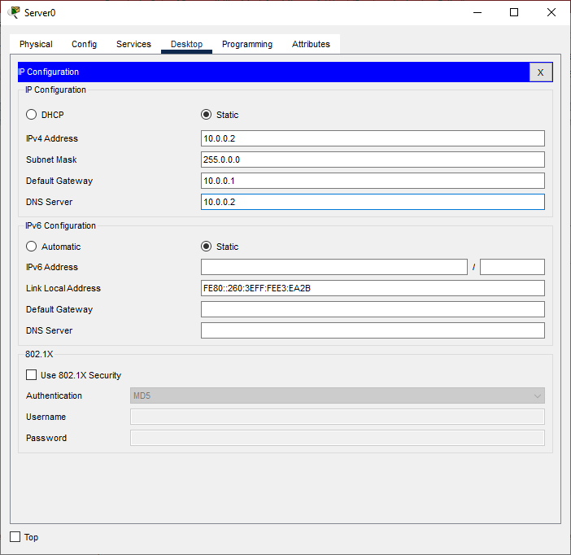

**Setting the Server for DNS service:**

We set the website ismile.com on the Server (10.0.0.2)

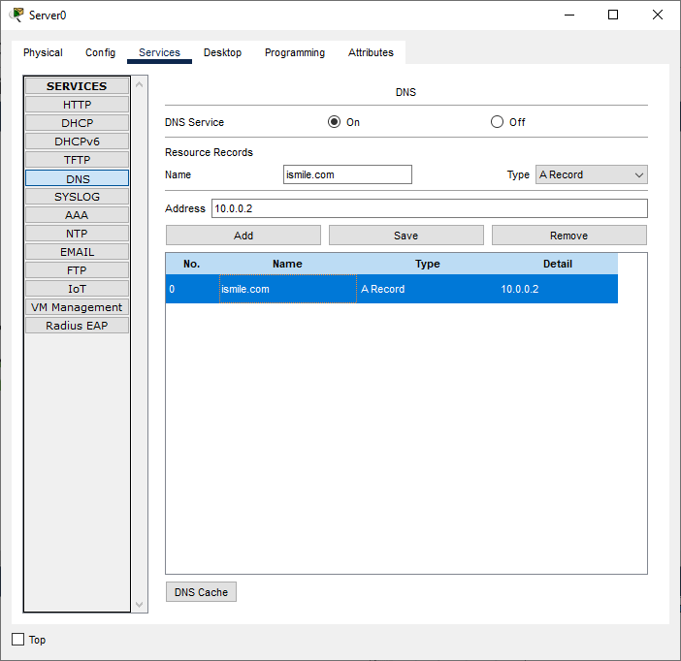

**PC0:**

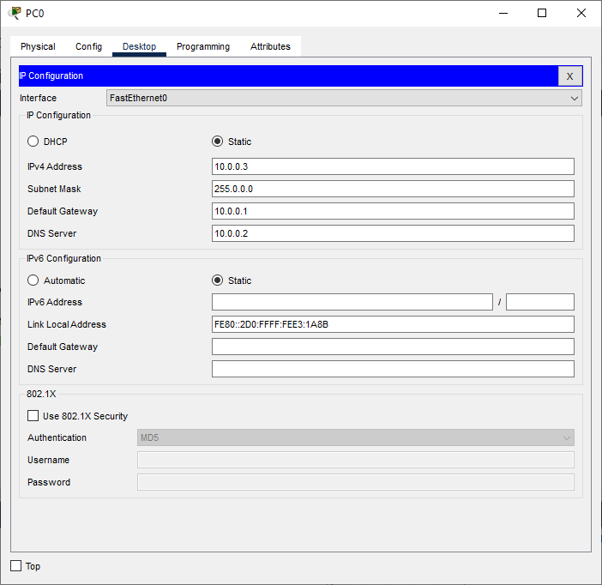

**PC1:**

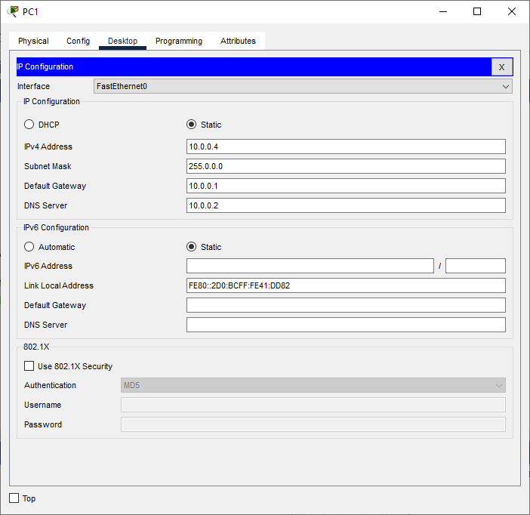

**PC2:**

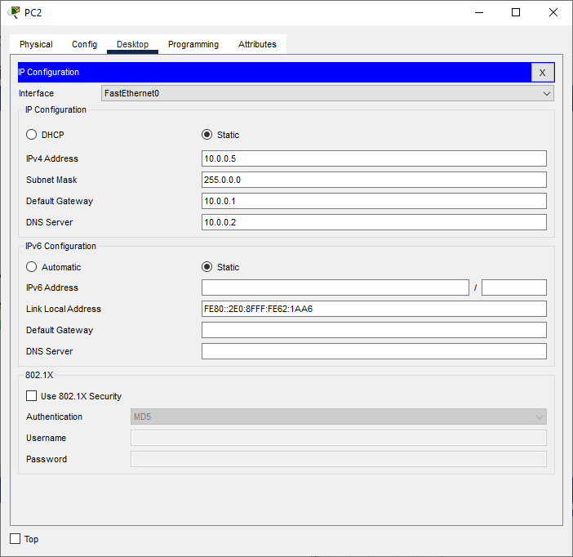

We verify the working of DNS as follows:

(Open the web browser of any PC and type [ismile.com](http://www.ismile.com) in the address bar)

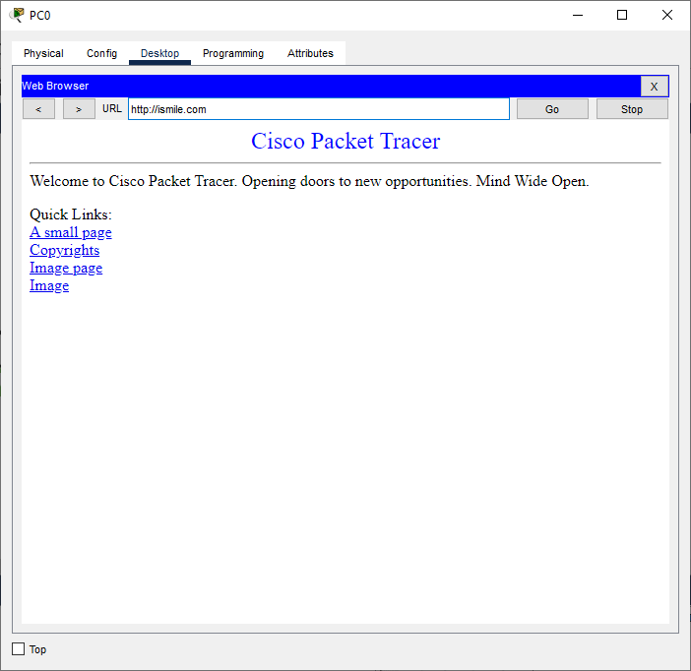

| For Video demonstration of the DNS, scan the QR-code |  |
| --- | --- |

1. **Configure HTTP**

HTTP stands for Hypertext Transfer Protocol. It is an application layer protocol used for transmitting and receiving data over the internet. HTTP is the foundation of data communication on the World Wide Web and is the standard protocol used for accessing websites, retrieving resources, and interacting with web servers.

When we type a URL (Uniform Resource Locator) into your web browser and press Enter, the browser uses HTTP to communicate with the web server hosting the website and request the specified resource (such as a web page, image, video, etc.). The server then responds by sending back the requested resource, and the browser interprets the data received to display the web page or resource to the user

We use the following topology



We use the following IP addresses for the given topology

|  | IP address | Default Gateway | Subnet  Mask | DNS  Server |
| --- | --- | --- | --- | --- |
| Router  Interface G0/0 | 10.0.0.1 |  | 255.0.0.0 | 10.0.0.2 |
| Server | 10.0.0.2 | 10.0.0.1 |
| PC0 | 10.0.0.3 |
| PC1 | 10.0.0.4 |
| PC2 | 10.0.0.5 |

**Configuring the Devices:**

**Router0:**



**Server:**



**Setting the Server for DNS service: (For HTTP we need to do set a website)**

We set the website ismile.com on the Server (10.0.0.2)



**Setting the Server for HTTP service:**

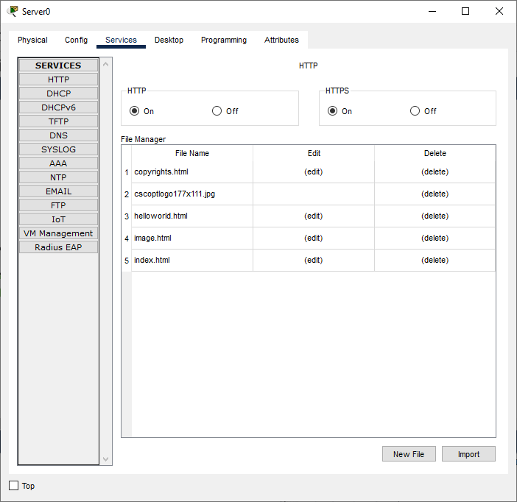

**PC0:**



**PC1:**



**PC2:**



We verify the working of HTTP as follows:

(Open the web browser of any PC and type [ismile.com](http://www.ismile.com) in the address bar)

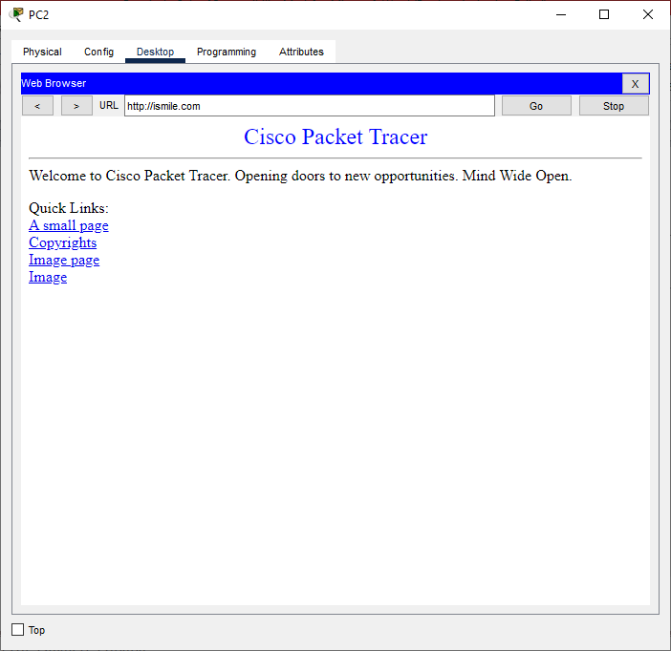

If we click on A small page we get the following.

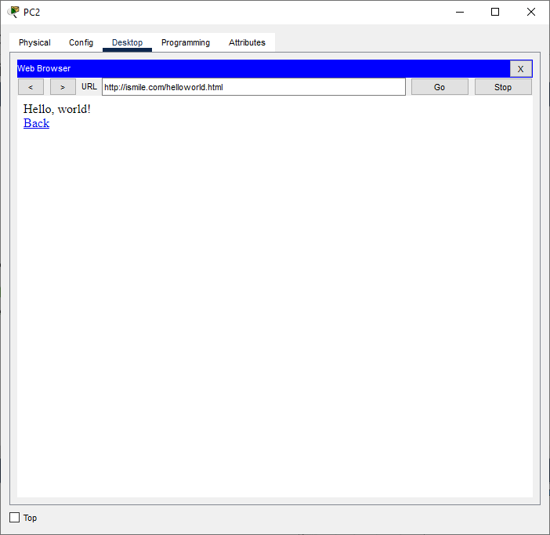

| For Video demonstration of the HTTP, scan the QR-code |  |
| --- | --- |

1. **Configure TELNET**

TELNET stands for "TErminal NETwork," and it is a network protocol used to establish a text-based interactive communication session between two devices over a computer network. It was one of the earliest protocols used to connect and communicate with remote computers.

In a TELNET session, one device acts as the client, and the other as the server. The client device initiates the connection to the server, and once the connection is established, the client can interact with the server through a command-line interface.

Originally, TELNET was primarily used for remote login and terminal access to mainframe computers and other multi-user systems. It allowed users to access resources and services on a remote machine as if they were sitting in front of it. However, due to security concerns, TELNET has largely been replaced by more secure protocols like SSH (Secure Shell), which encrypts the data transmitted over the network and provides better protection against unauthorized access and eavesdropping

We use the following topology



We use the following IP addresses for the given topology

|  | IP address | Default Gateway | Subnet  Mask |
| --- | --- | --- | --- |
| Router  Interface G0/0 | 10.0.0.1 |  | 255.0.0.0 |
| Server | 10.0.0.2 | 10.0.0.1 |
| PC0 | 10.0.0.3 |
| PC1 | 10.0.0.4 |
| PC2 | 10.0.0.5 |

**Configuring the Devices:**

**Router0:**



**Server:**



**PC0:**

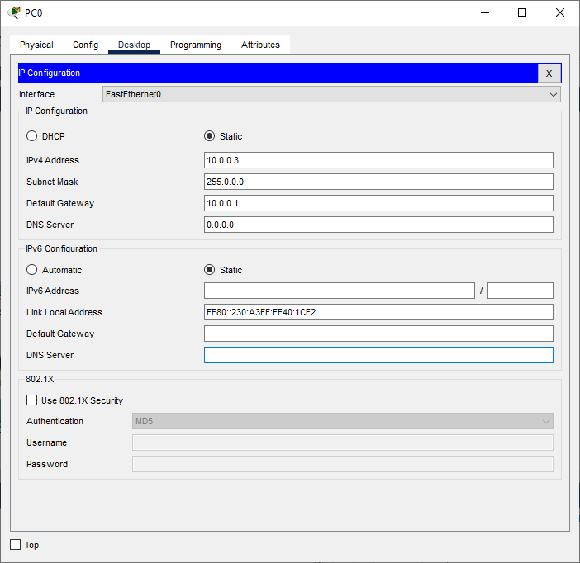

**PC1:**

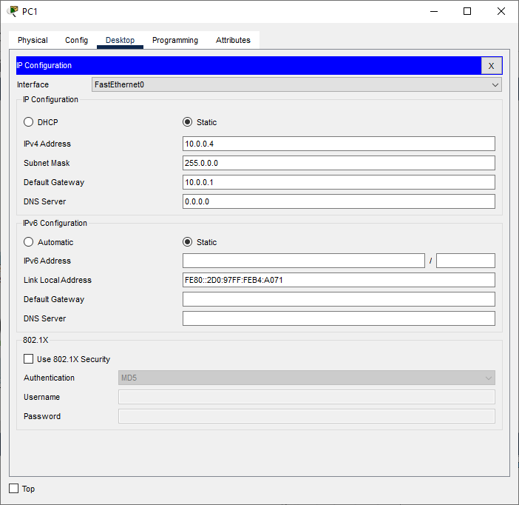

**PC2:**

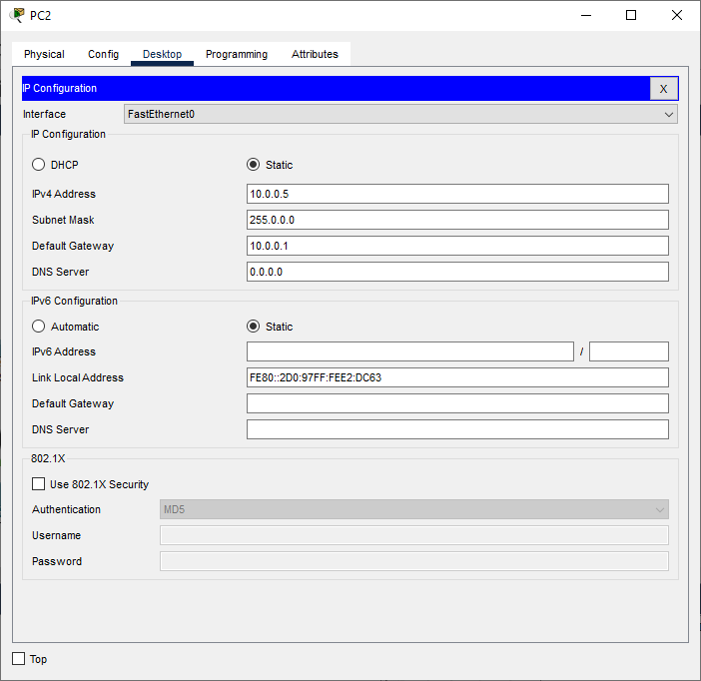

Type the following command in the CLI mode of the Router

Router>enable

Router#

Router#configure terminal

Router(config)#

Router(config)#hostname smile

smile(config)#

smile(config)#line vty 0 4

smile(config-line)#

smile(config-line)#password cisco

smile(config-line)#login

smile(config-line)#enable secret cisco

smile(config)#exit

smile#

To verify the TELNET protocol, we type the following commands in any of the PCs

telnet 10.0.0.1

Password: cisco

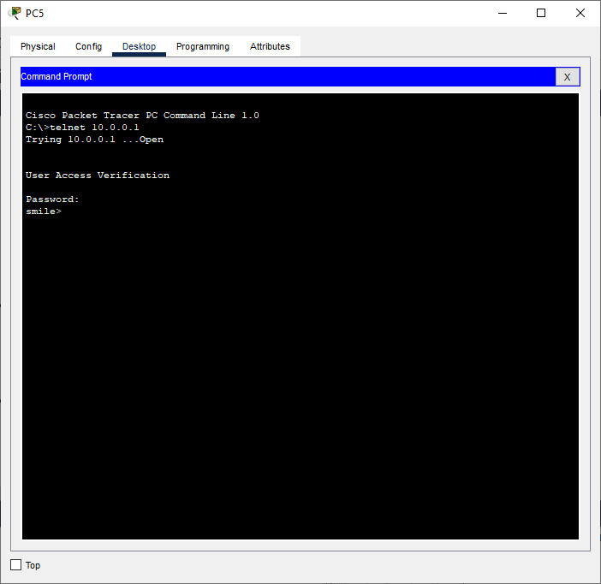

| For Video demonstration of the TELNET, scan the  QR-code |  |
| --- | --- |

1. **Configure FTP**

FTP stands for "File Transfer Protocol." It is a standard network protocol used to transfer files between a client and a server on a computer network, such as the Internet or an intranet. FTP allows users to upload and download files, as well as perform various file operations on remote systems.

The FTP communication typically involves two entities: the FTP client and the FTP server. The FTP client is the software running on the user's local computer that initiates the file transfer request, and the FTP server is the remote system that stores and manages the files.

We use the following topology



We use the following IP addresses for the given topology

|  | IP address | Default Gateway | Subnet  Mask |
| --- | --- | --- | --- |
| Router  Interface G0/0 | 10.0.0.1 |  | 255.0.0.0 |
| Server | 10.0.0.2 | 10.0.0.1 |
| PC0 | 10.0.0.3 |
| PC1 | 10.0.0.4 |
| PC2 | 10.0.0.5 |

**Configuring the Devices:**

**Router0:**



**Server:**



**Configure the Server for FTP service as follows**

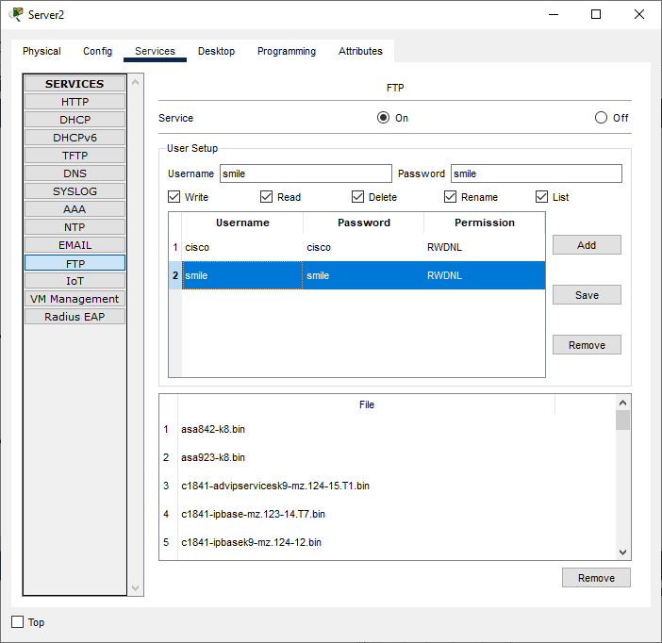

**PC0:**



**PC1:**



**PC2:**



To verify the FTP protocol, we type the following commands in any of the PCs

ftp 10.0.0.2

Username: smile

Password: smile

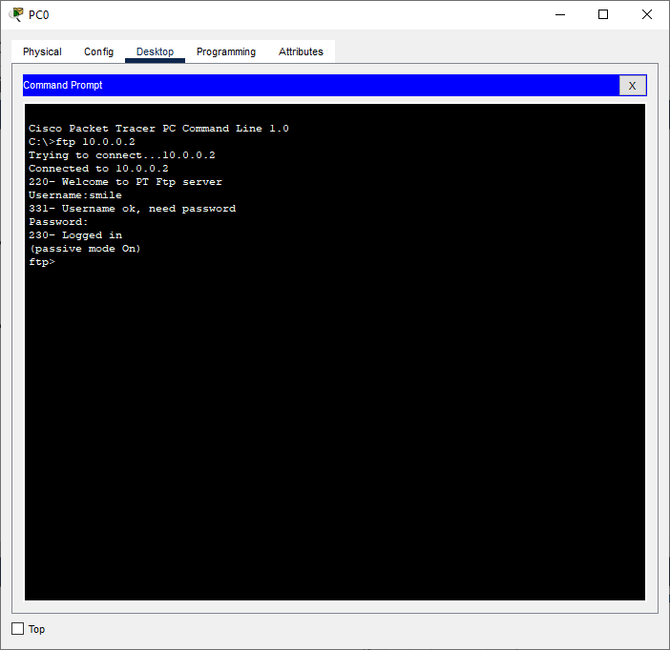

| For Video demonstration of the FTP, scan the QR-code |  |
| --- | --- |